# PROJECT TITLE

Tropical Cyclone Prediction in Australia by Litesh Samji

Details of all tropical cyclones that are known to have occurred are contained in a database maintained by the Bureau of Meteorology. After a tropical cyclone has occurred, tropical cyclone meteorologists reanalyse the cyclone data and compile what is known as the 'best track' and a report.

The data set has been collected from the [Bureau of Meteorology](http://www.bom.gov.au/cyclone/tropical-cyclone-knowledge-centre/databases/) and contains historical data from 1907 till present year 2021. For the purpose of the project the data set has been scaled back to only include year on year data from 1990 till present year.

Dataset fields:

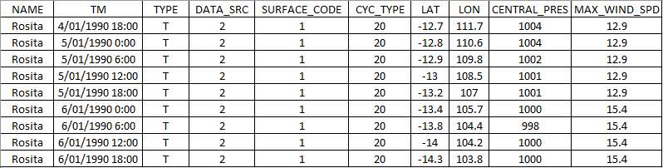

## Problem Analysis

This project aims to answer the following questions:

* Number of cyclones and the frequency?
* Can we predict the wind direction of upcoming cyclones with machine learning?
* Is there a correlation with Central Pressure and the cyclone duration?

## Visualisations

* Australian map showing the top 10 cyclones by wind speed and central pressure
* Line plot depicting

1. Central pressure vs time
2. Maximum wind speed over duration
3. Central pressure vs max wind speed

## Technologies

ETL: Python, Pandas

API: Flask

Visualisation: JavaScript (D3, Plotly, Leaflet) HTML/CSS: Bootstrap

Machine Learning: Scikit-learn/Deep Learning

Project flow chart:

